Jane Irish E. Ayop

BAELS3B

**Future Philosophies**

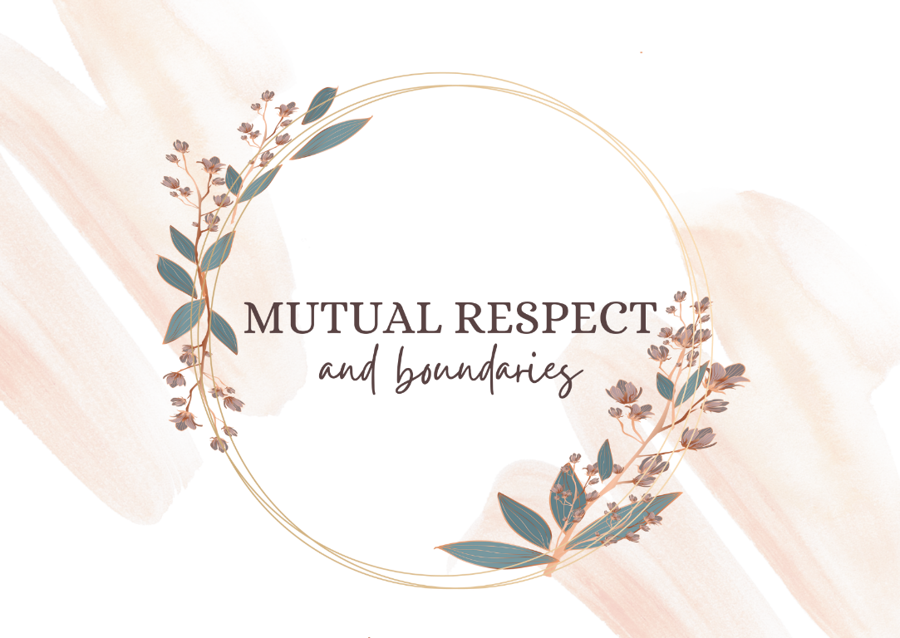

My philosophy as a teacher revolves around mutual respect and boundaries. I want my student to not fear me but to understand that in my classroom **basic respect** is in place and valued. I as a teacher will always respect their boundaries as a student and in turn, if they still can’t respect me as their teacher, they will have to respect me as a person. Since I respect my students, I understand that they have and can formulate their own opinions and that one couldn’t force respect. Thus, as a teacher it is my responsibility to attain my student’s respect.

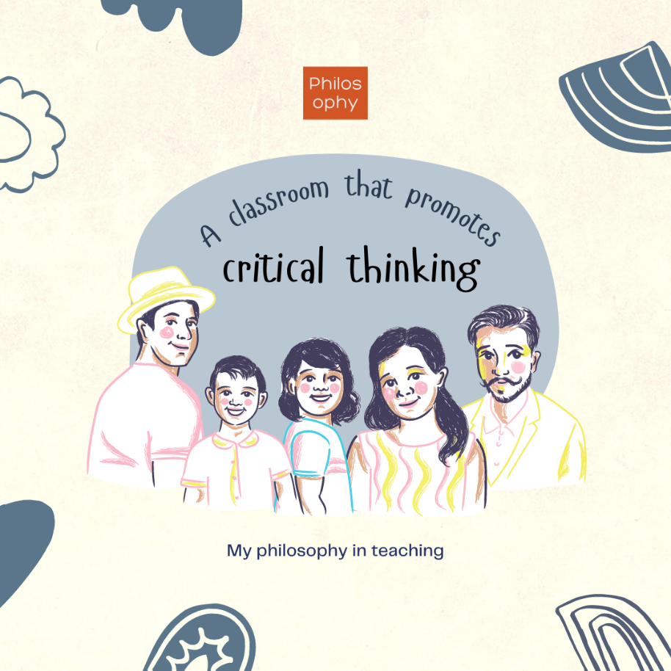

In teaching, I want to create a classroom where my students can think critically. I want to teach them how to question everything. They will know how to question me, my teaching, their grades, the lesson, the materials presented, the society, the government, the rules, and everything with respect still being in place. I want them to grow not as a person that blindly follows rules, but as a person that can think on their own and be a person of themselves.

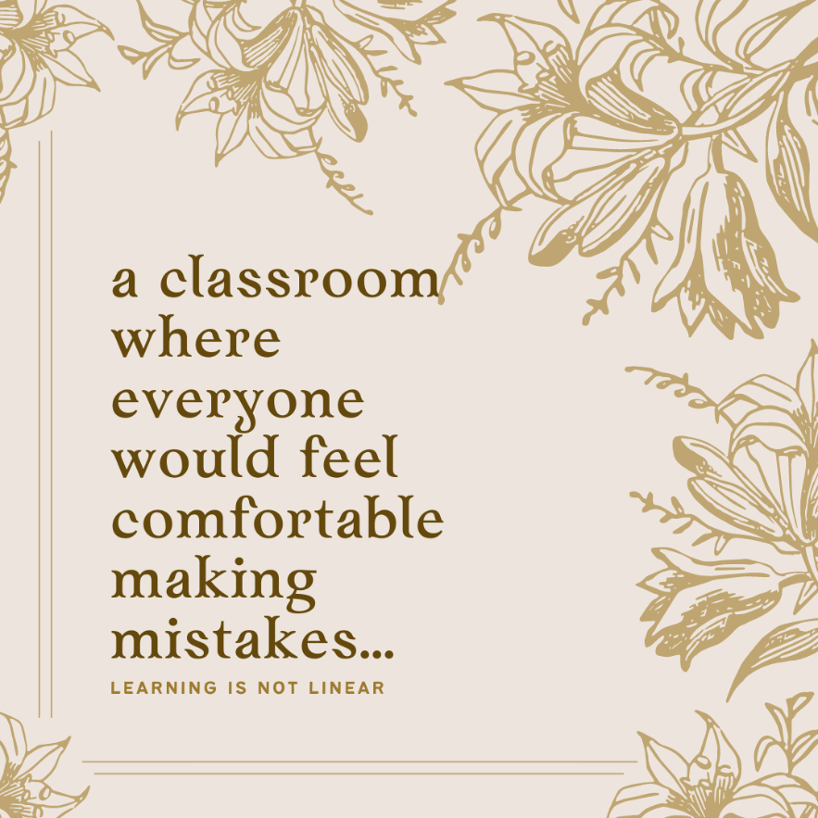

In evaluating students, I want to create a classroom or an environment where everyone would feel comfortable making mistakes. Where mistakes are not seen as a drawback but as an opportunity to learn more. My students have to realize that they're human and that they don't have to be hard on themselves, because everyone deserves a second, a third, a fourth, and many chances. Thus, in evaluating them, I mostly look at their efforts in learning.